**Scenario-1 –**Reset PW Before 30 days Interval

User Story:  
As a user, I want to securely reset my password before 30 days using the same password, so that I can change my password for security reasons.

Acceptance criteria:  
User will need to enter the following input data fields:

1. New Password
2. Re-enter New Password

New Password data field specifications - At least 1 number, 1 uppercase letter, 1 lowercase letter, one special character  
New Password cannot be same as previously used password

Show password criteria to the user

New Password and Re-enter New Password entry should be masked while user types it

**“Green check mark”** next to 'New Password' data field should be displayed that indicates to the user after typing password that the entry meets criteria

**“Red cross mark”** next to 'New Password' data field should be displayed that indicates to the user after typing password that the entry does not meet criteria

**Validate those inputs** - in 'New Password' and 'Re-enter Password' data fields match

**“Green check mark”** next to 'Re-enter' password data field should be displayed that indicates to the user after typing if passwords match

If password entered does not match criteria specified and user hits Submit, show error alert **"Password entry does not meet criteria"**

If entries in 'New Password' field and 'Re-enter Password' do not match and user hits Submit, show error alert **'Password entries do not match'**

After successful validation of all entered password fields and on clicking Submit, show message indicating **“successful password reset”** and route user to Login screen

User Storey:

**Scenario-2 –** Forgot Password / Login failed after 3 attempts -

User Story:  
As a user, I want to securely reset my forgot password, so that I can change my password for security reasons.

Acceptance criteria:  
1. Tap to Forgot Password.

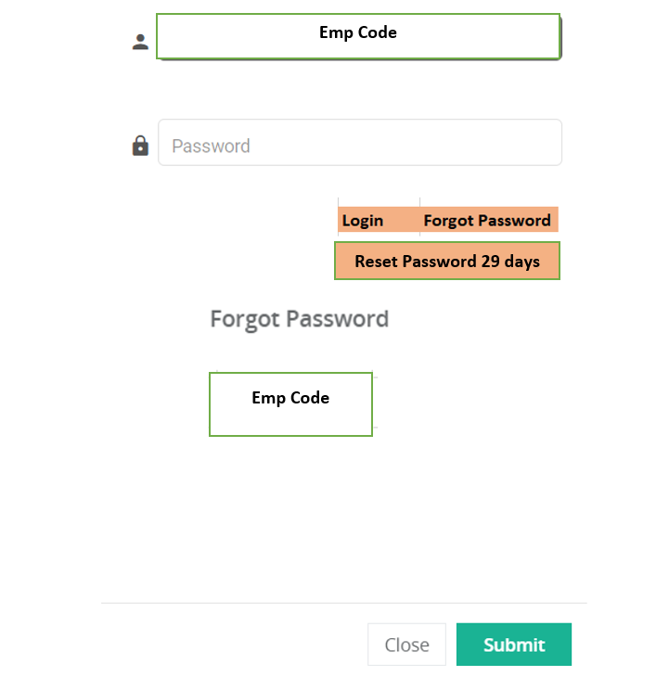

Your Reset Password Notification Successfully Sent to Admin – Contact Admin for your New Password.

1. Manual - User inform the Supervisor or Line In-charge to send mail notification for Forgot PW with Credential Details.
2. PW reset notification sent to Admin Bucket BCI Application – Admin should login to the BCI App for reset of PW.

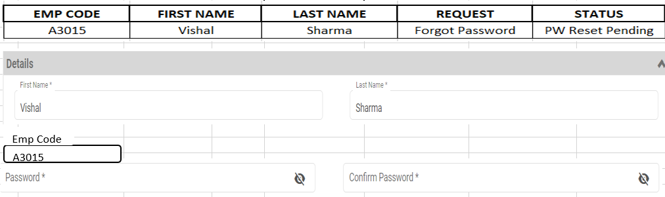

1. After successful validation of all entered password fields and on clicking Submit, show message indicating **“successful password reset”**.
2. Admin share the New PW details in mail to Supervisor or Line In-Charge.
3. Manual System – Supervisor inform the User for New PW.
4. User Login to Application using New Password

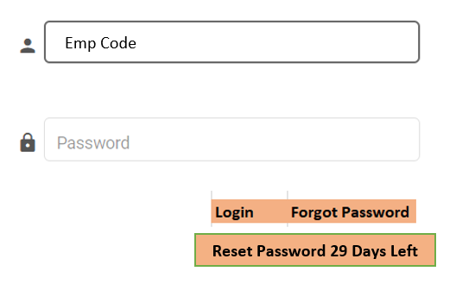

1. Tap Login – Reset PW option Pop-up.

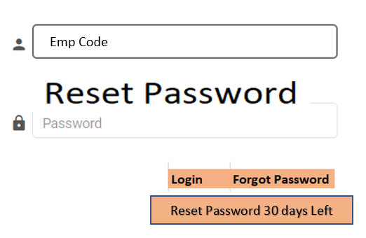

1. Tap Reset Password





1. User Reset his PW. Pop-up message **“Your Password has been reset successfully”.**
2. Route the user to Login screen.

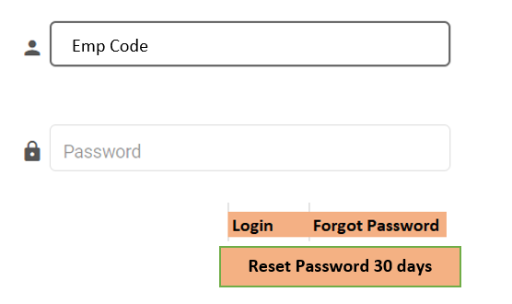

# How admin will reset the PW Access the Screen:

By clicking on the “Reset PW Request” row on the Password Management Screen.

# Preconditions:

The user should be logged in the BCI app and should be on the Password Management Screen.

# How user will reset the New PW Access the Screen:

After Login with new PW – Pop-up message for “Reset PW Request” on the Login Screen.

# Preconditions:

The user should put login detail on the BCI app.

Deactivate a user:

User record cannot be deleted so in order to stop the user from logging into BCI PMMS Application administrator need to deactivate them.

**Screens Changes required for User management:**

1. **User ID –** Emp Code. (Mandatory Field)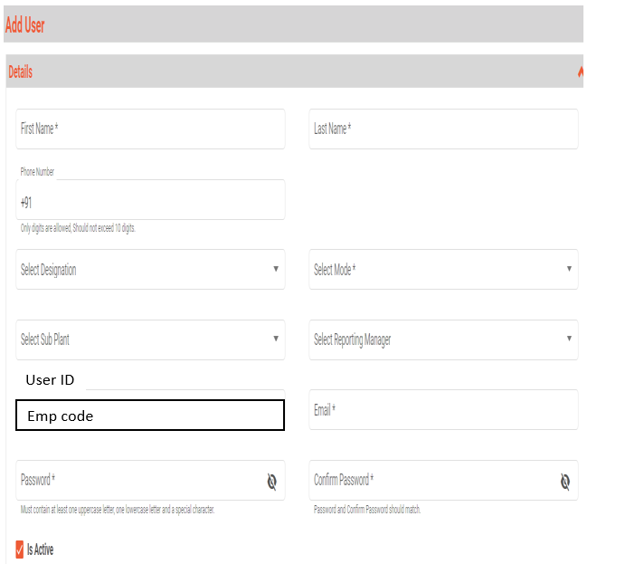
2. User Management.

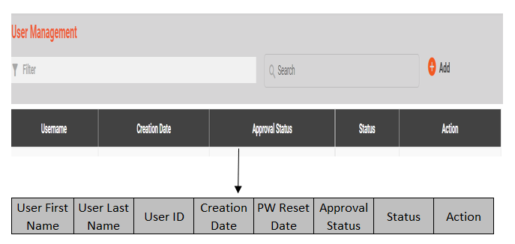

1. Link up Required – User Management page and Password Management Page.
2. PW Reset Time/Date should be captured for Audit Trail.
3. Login page link up required.
4. Reset Password 30 days will link up with PW Reset Time/Date.

|  |  |  |  |
| --- | --- | --- | --- |
| **CHANGES REQUIRED** | | | |
| Sr. No. | **CURRENT SCENARIO** | **CHANGES REQUIRED** | **REMARKS** |
| 1 | User Management ----Add User ------**User Name** | User Management ----Add User ----**User Id as Emp Code** | **User Name Field Changed to Emp Code** |
| 2 | User Management ---- Filter ---- Data Field -- | User Management ---- Filter --- Data Table Field -- | Additional Data Field to map PW Reset Time/Date |
| 1.  User Name | 1.  **User First Name** |
| 2.  Creation Data | 2.  **User Last Name** |
| 3.  Approval Status | 3.  **User ID** |
| 4.  Status | 4.  Creation Data |
| 5.  Action | 5.  **PW Reset Time/Date** |
|  | 6.  Approval Status |
|  | 7.  Status |
|  | 8.  Action |
| 3 | Login Page -- Username | Login Page --- **Emp Code** |  |
| 4 | Login Page --  No Reset PW Option for User | Login Page --- **Reset PW 30 days Left** | Additional field added |
|  |  |  |  |
| **Linking of Fields** | | | |
| 1 | User Force Reset Password | User Management -- Filter -- Data Table Field -- **PW Reset Date/Time** | Change/Reset Password -- Capturing the record of Time/Date |
| 2 | Admin Reset Password | User Management -- Filter -- Data Table Field -- **PW Reset Date/Time** | Change/Reset Password -- Capturing the record of Time/Date |
| 3 | User Change Password Before 30 Days | User Management -- Filter -- Data Table Field -- **PW Reset Date/Time** | Change/Reset in Password -- Capturing the record of Time/Date |

**Super Admin Password Management:**

Super admin can reset his own password before 30 days reset password option.

**Steps:**

**Super Admin Forgot Password:**

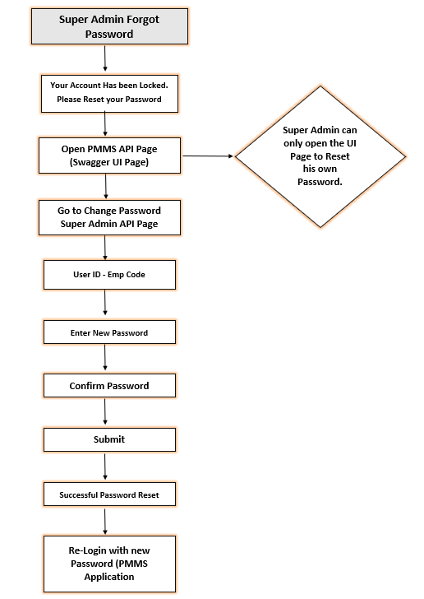

|  |  |  |
| --- | --- | --- |
| **PASSWORD MANAGEMENT HIERARCHY** | | |
| **USER** | **ADMIN** | **SUPER ADMIN** |
| WMS User | Mr. Rahul Das | Mr. Sandeep Amlekar |
| WIP User | Mr. Pallab Deka | Mr. Sandeep Amlekar |
| FG User | Mr. Rahul Das | Mr. Sandeep Amlekar |

